Image to 3D Visualization by detection in
Augmented Reality
Penchala Vamsi Chebrolu¹
¹Dept. of MCA, Narayana Engineering College, JNTUA University,
Nellore, Andhra Pradesh, India
¹penchalavamsic@gmail.com

Abstract— Visual understanding in education is crucial for effective learning. However, traditional 2D educational materials may not fully engage students in complex subjects. The backdrop of enhancing visual understanding in education can be updated through 3D visualization using augmented reality (AR) which is accessible on mobile devices, with the help of C# scripting language. Pointing out the desired image with the camera, the application detects with image training model consisting of blob detection and corner detection. Then scale, and rotation work by pose estimation with the help of anchor points, final visual representation is done by rendering. This process will help the students to better understanding.

Keywords: Augmented Reality, Detection. Rendering

1. INTRODUCTION
Augmented reality (AR) enhances education by overlaying digital information onto the real world. It engages students with interactive 3D models, making complex subjects more accessible. AR in education fosters deeper understanding and brings abstract concepts to life, improving learning outcomes. To enhance the visualization of students I designed an application that can be accessible through mobile devices. Unity Engine is the development platform chose for C# scripting with AR foundation package.
- Literature Survey
Image Recognition in Augmented Reality: A comprehensive Survey

Dieter Schmalstieg, Tobias Hollerer authored this paper as
a survey that talks about image recognition in Augmented Reality (AR). It provides an extensive overview of image recognition techniques and technologies within the context of Augmented Reality. Mainly about marker-based tracking and natural feature tracking and applications of image recognition in AR, including navigation, medical training.

Real-time Object Detection for Augmented Reality

T.K.Le, P.Luong, K. N. Ngan authored this paper and published in the proceedings of the 2023 IEEE. This paper proposes a real-time object detection framework for augmented reality (AR) applications. The framework is based on a single-stage deep learning model, which is able to detect objects in real time with high accuracy. The model is trained on a large dataset of synthetic and real-world images, and it is able to detect a wide range of objects, including people, animals, vehicles, and furniture.
- Problem definition
At present every student facing issue with theoretical learning techniques which reduces interest, visual thinking. Theoretical learning techniques leads to low practical experience which effects on the student career. Visual representation is much more beneficial than theoretical representation. Representation may not be possible in all cases.
4. OBJECTIVES OF PROJECT
The main objective of the project is making visual thinking easier to students. The tasks which are involved in the project divide into four. They are:
- Scanning
- Detecting
- Rendering
- Representing
5. ENVIRONMENT

The project has hardware and software environments.

5.1 Hardware Environment:

The following is the hardware requirement:
- Mobile device with camera.

5.2 Software Environment:

The following software have used for the development.
- Unity Game Engine.
- AR Foundation Package.
- ARCore
- Blender
- C#

6. IMPLEMENTATION

6.1 Graphical Representation:

The following figure 6.1 represents the flow of the project

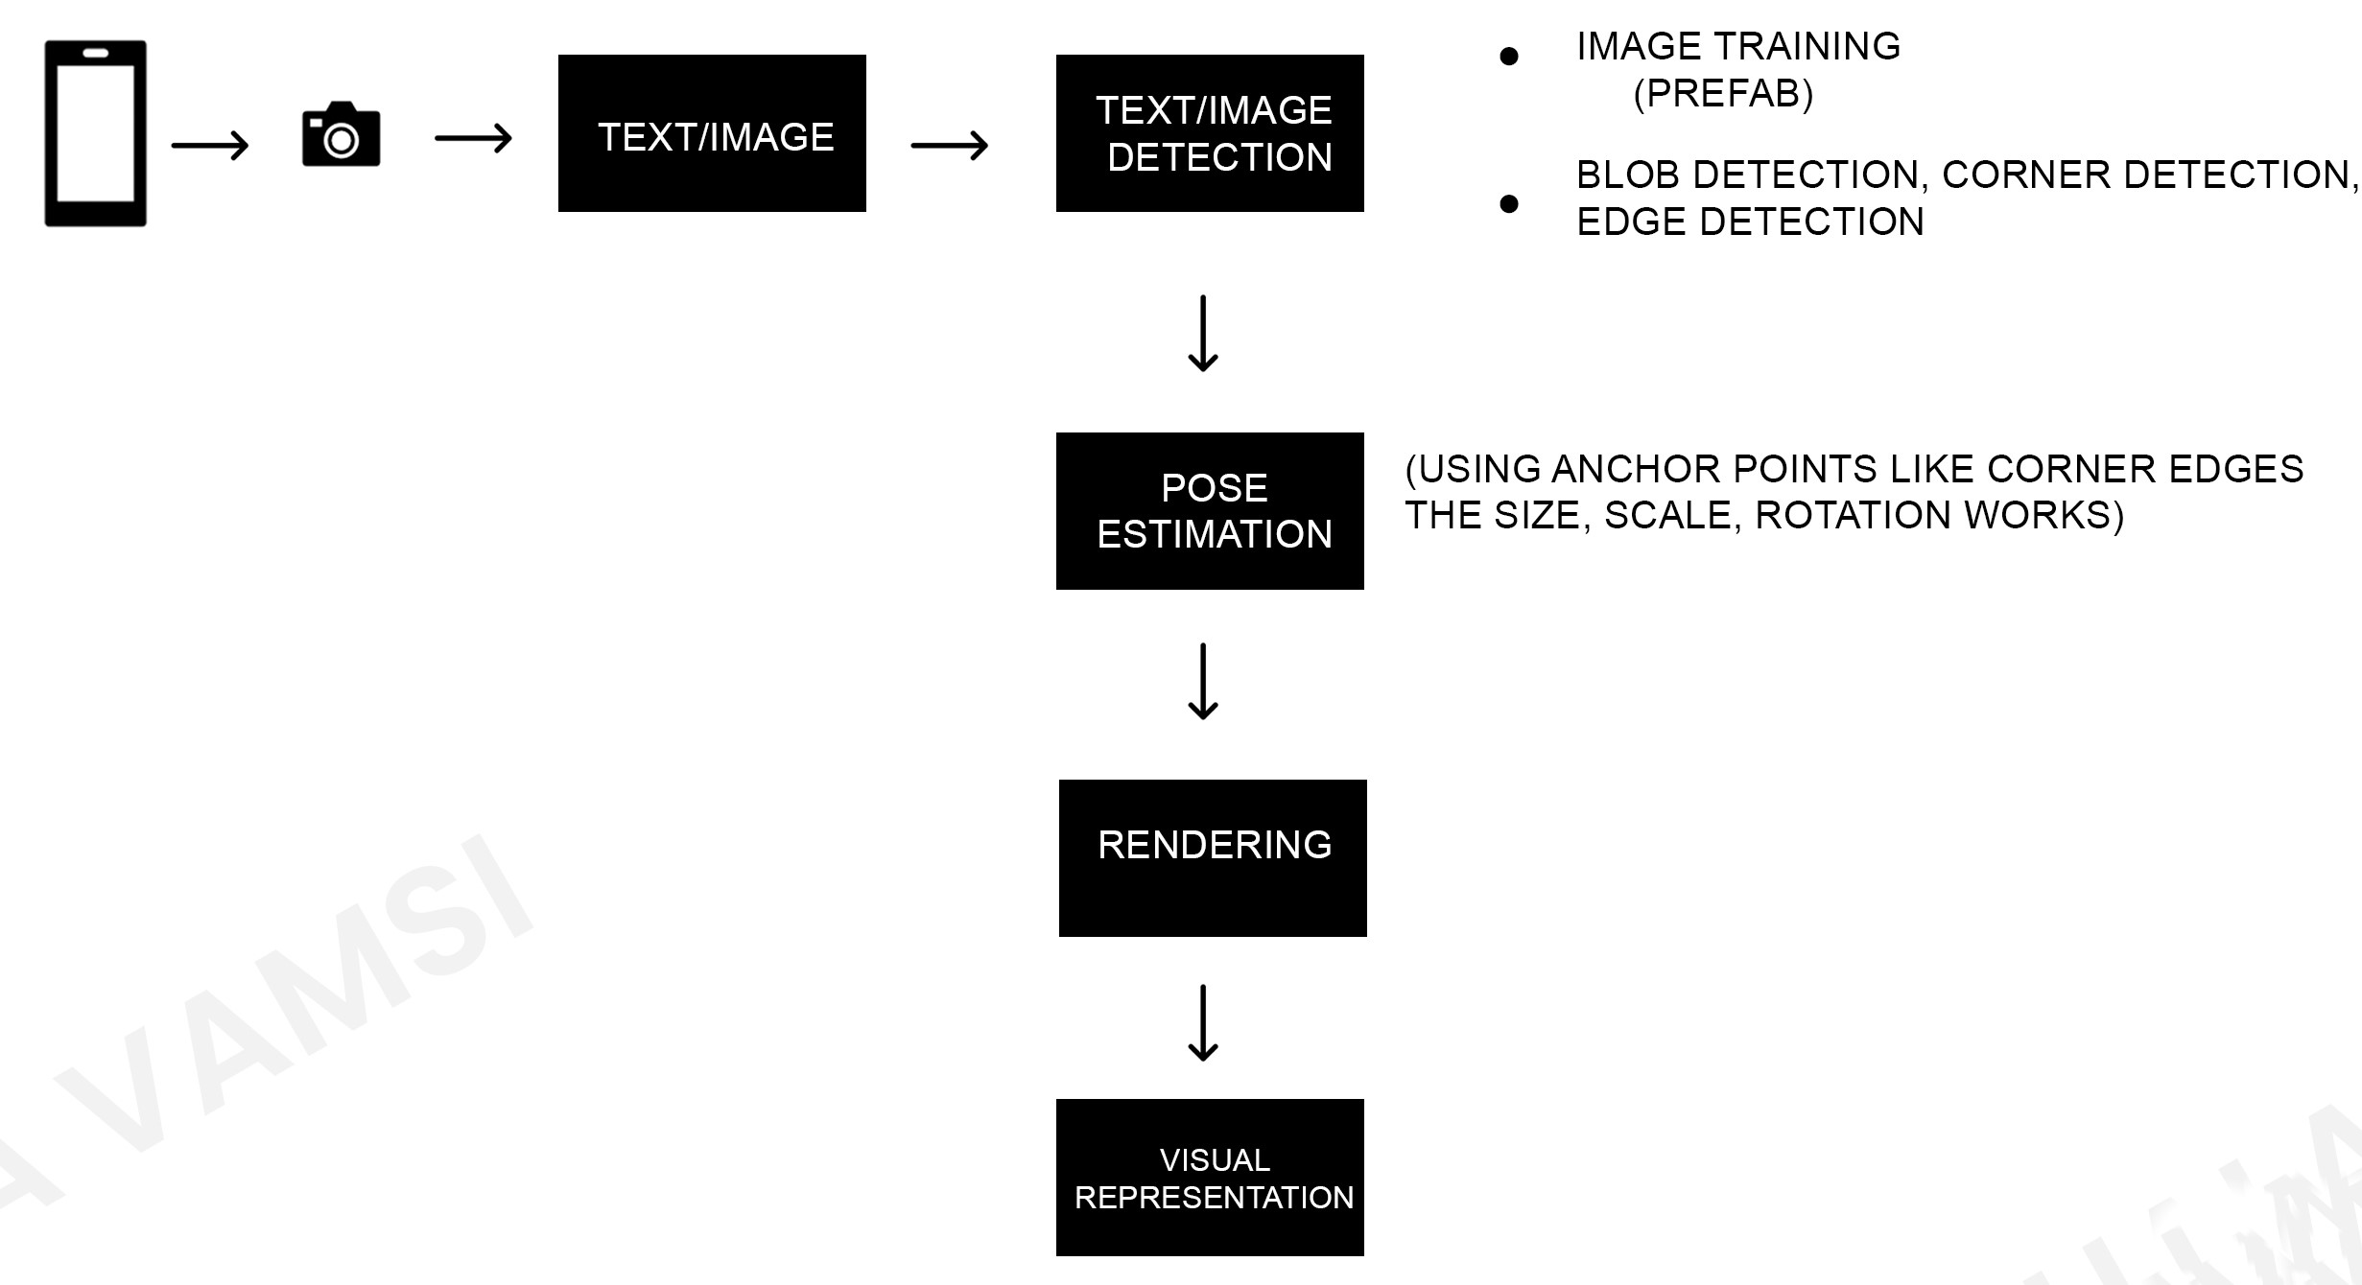
Fig 6.1 Flow of the project

The figure 6.1 represents the flow of the project. The flow starts with the scanning of text or image with help of the camera. Image training helps to identify the text/image which is called a prefab.
Using detection techniques like blob detection, corner detection, edge detection the detection process will continue to estimation of pose. Anchor points which are helpful to size, scale, rotation is worked based on the corners and edges.
Rendering is the last second step involved in the flow of the project which plays major role in visualization.

6.2 Working:

Camera is used for scanning an image or text by capturing a digital image of the document and then using software to process the image and extract the text. This process is called optical character recognition (OCR).
There are a number of different ways to use a camera to scan an image or text. One common method is to use a flatbed scanner. A flatbed scanner is a device that holds the document to be scanned flat on a glass surface. The scanner then moves a light source and a sensor across the document to capture the digital image.
Another common method of scanning images and text is to use a portable scanner. Portable scanners are smaller and lighter than flatbed scanners, and they can be used to scan documents without having to remove them from a binder or other enclosure.
After scanning with camera detection continues,Image detection using image training in augmented reality (AR) is the process of using machine learning to train a computer model to recognize specific objects or scenes in images. This model can then be used to place virtual objects or information in the real-world using AR technology.
To train an image detection model, you will need a large collection of images of the objects or scenes that you want the model to be able to recognize.
Once your model is trained, you can use it to detect objects or scenes in images in real time. To do this, you will need to use an AR framework such as ARCore or ARKit to track the position and orientation of the user's device. The AR framework will then use your image detection model to identify any objects or scenes in the camera's view. Once the objects or scenes have been identified, the AR framework can place virtual objects or information in the real world at the corresponding locations.
ARCore is a software development kit (SDK) developed by Google that allows developers to build augmented reality (AR) applications for Android devices. ARCore uses a variety of sensors, including the camera, gyroscope, and accelerometer, to track the position and orientation of the user's device in the real world. This information is then used to place virtual objects and information in the real world in a realistic way.

Blob detection in AR can be used to identify and track a variety of different objects, such as:

Plane surfaces: Blob detection can be used to identify and track flat surfaces in the real world, such as tables, floors, and walls. This information can then be used to place virtual objects on the surfaces in a realistic way.
Objects: Blob detection can be used to identify and track specific objects in the real world, such as products, tools, and machinery. This information can then be used to provide users with information about the objects or to allow them to interact with the objects in a virtual way.
Faces: Blob detection can be used to identify and track faces in the real world. This information can then be used to create AR experiences that interact with the user's face in new and innovative ways.
Anchor points are typically flat surfaces, such as tables, floors, and walls. They can also be specific objects, such as chairs, doors, and windows. By identifying and tracking anchor points, AR applications can accurately place virtual objects in the real world.
Pose estimation using anchor points is a powerful tool that can be used to create a wide range of AR applications.

Rendering and visualization in augmented reality (AR) is the process of creating and displaying virtual objects and information in the real world in a realistic way.

Rendering is the process of converting a 3D model into a 2D image. This is done by calculating the position and colour of each pixel in the image based on the 3D model and the lighting conditions in the scene.

Visualization is the process of displaying information in a way that is easy to understand. In AR, visualization is used to display virtual objects and information in the real world in a way that is realistic and informative.

Rendering and visualization are essential components of AR applications. Without rendering and visualization, it would not be possible to create realistic and informative AR experiences.

7. Results

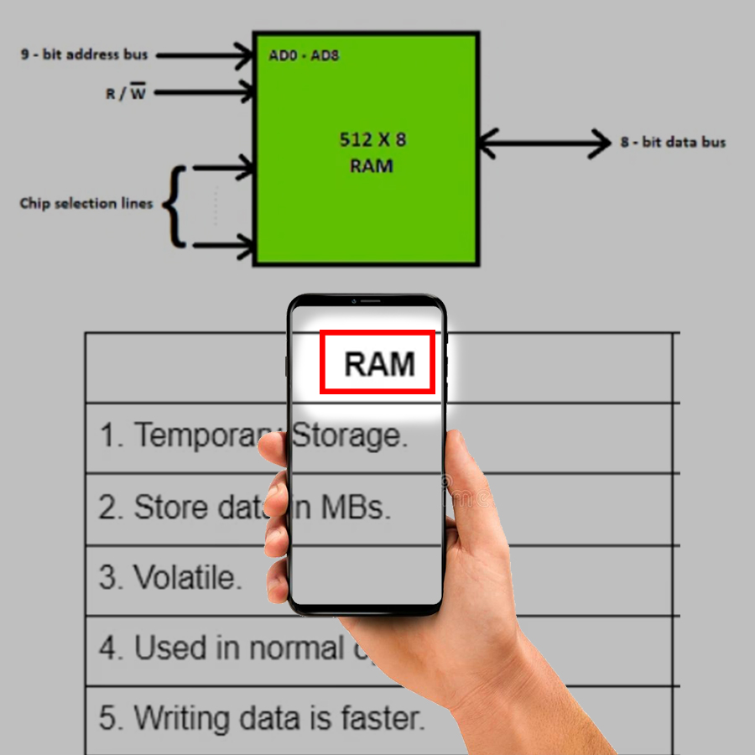

Fig 7.1 Detection of image.

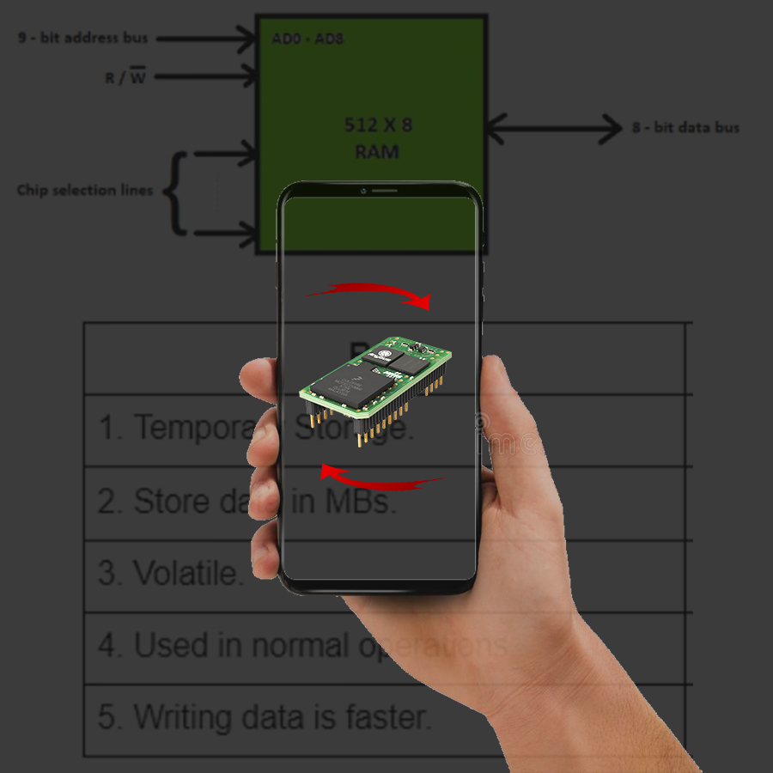

Fig 7.2 Three-Dimensional visualization using in AR

Some more expected results are shown below

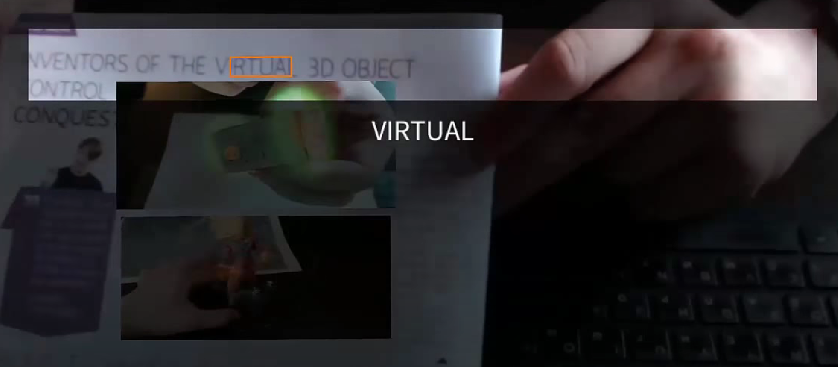
Fig 7.3 Detection of word virtual
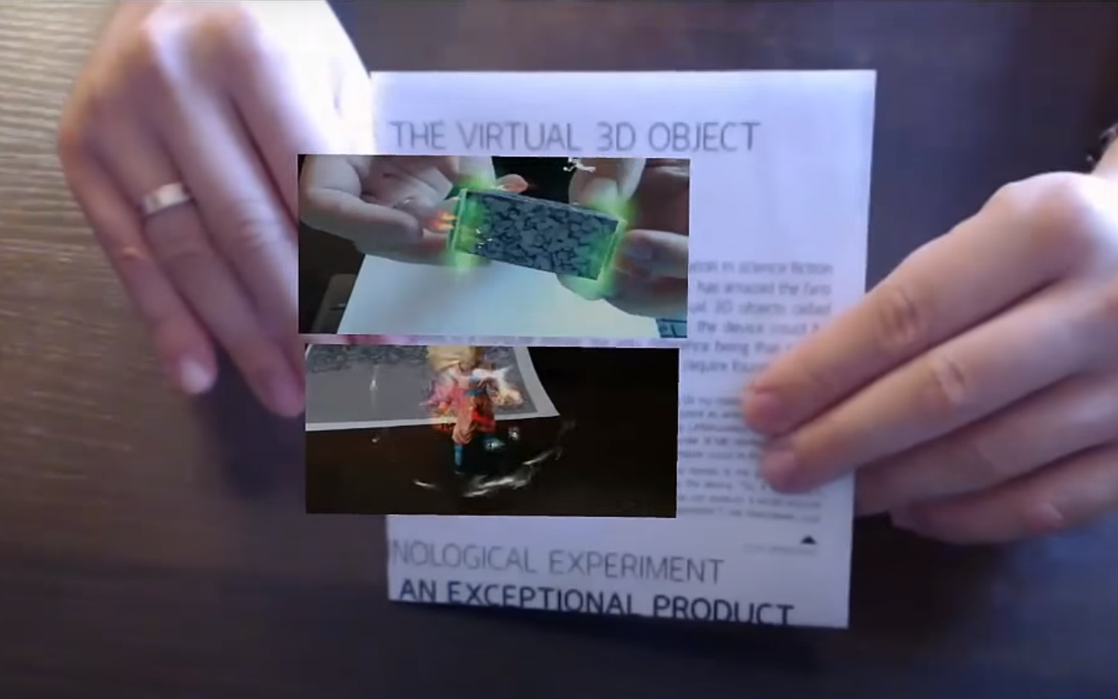

Fig 7.4 Visual representation of virtual word

8. FUTURE SCOPE
Following are the two major areas where the improvement cab be done:

1. The detection technique can be improved by including multiple methods of detection at a time for fast and robust detection.

2. Rendering process can also be improved by using low poly models for fast processing.
- Conclusion
Hence, I conclude that this project helps to better understand of the subject for student compared to the general method.

By developing this project as a application brings a major change in the method of studying and understanding.

References
- Image Recognition in Augmented Reality: A comprehensive Survey by Dieter Schmalstieg, Tobias Hollerer
- Real-time Object Detection for Augmented Reality byT.K.Le, P.Luong, K. N. Ngan authored this paper and published in the proceedings of the 2023 IEEE.

Author Profile:

Penchala Vamsi Chebrolu, I MCA, Narayana
Engineering College, JNTUA University,
Nellore, Andhra Pradesh, India

